Project Design / Planning Phase
Solution Architecture
Date | 15 October 2026
Team ID | SWTID-2026-6181
Project Name | AI FITTRACK API
Maximum Marks

Solution architecture bridges the project problem and the technology solution. The architecture below follows the supplied template's requirement to describe structure, behavior, features, development phases, and solution requirements.
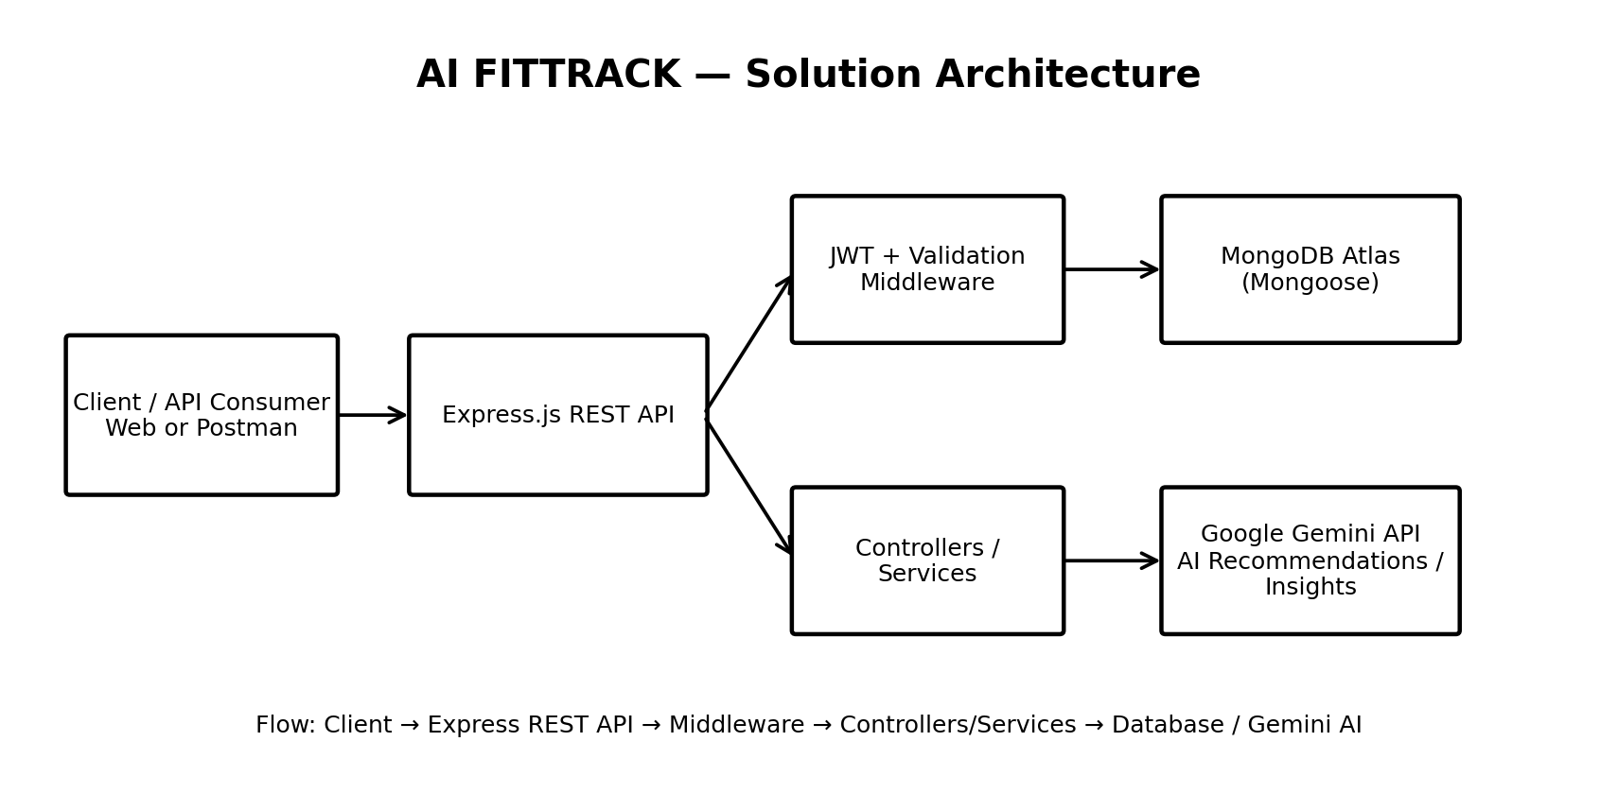

Architecture Components
Component | Role / Description | Technology
Client / API Consumer | Sends requests and receives API responses. | Web/API client, Postman
REST API | Exposes application endpoints and coordinates requests. | Node.js, Express.js
Authentication & Validation | Protects routes and validates authenticated requests. | JWT, middleware
Controllers / Services | Implements business logic for workout CRUD, search and AI features. | JavaScript / Node.js
Database | Stores user and workout information. | MongoDB, Mongoose, MongoDB Atlas
AI Service | Generates personalized fitness recommendations and insights. | Google Gemini API

Development Phases
- Phase 1: Registration, authentication, and workout creation.
- Phase 2: Workout update, deletion, search, and recommendation features.
- Phase 3: AI fitness insights and integration refinement.
- Testing and deployment preparation: API validation, UAT, error handling, and protected-route verification.
Source template: Solution Architecture.docx.

